**School** **height** **and** **weight** **measurements**



**Every** **year,** **throughout** **England,** **more** **than** **a** **million** **children** **in** **Reception** **and** **Year** **6** **have** **their** **height** **and** **weight** **measured** **at** **school** **as** **part** **of** **the** **National** **Child** **Measurement** **Programme**

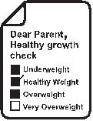

**PARENTS** **ARE** **NOTIFIED**

**SCHOOL** **HEIGHT** **&** **WEIGHT** **CHECKS**

**PARENTS’** **FEEDBACK** **LETTER**

**PARENTS’** **DATA** **ACTION** **USE**

Parents receive Measurements are

a letter about carried out by trained measurement day staff e.g. school

at their child’s school. nurse assistant. The letter tells Children take off

parents how children their coat and shoes are measured, what for a more accurate data is collected, measurement.

and why.

**Every** **year** **in** **England,** **over** **a** **million** **children** **in** **Reception** **(aged** **4-5)** **and** **Year** **6** **(aged** **10-11)** **have** **their** **height** **and** **weight** **measured** **to** **calculate** **their** **weight** **status.**

Most areas send parents a confidential letter about their child’s weight status within 6 weeks of measurement.

**87%** of parents say

they find the NCMP feedback helpful.

A parent can speak to their school nurse or GP for further advice and support about their child’s weight and growth.

Parents can visit the

[**children’s weight**](https://www.nhs.uk/healthier-families/childrens-weight/)

page at Better Health

- Families for tips on

healthier changes.

Parents can monitor

their child’s weight by

visiting the

**[NHS healthy](https://www.nhs.uk/health-assessment-tools/calculate-your-body-mass-index/)**

**[weight calculator.](https://www.nhs.uk/health-assessment-tools/calculate-your-body-mass-index/)**The data is held by the local authority and sent to NHS England and Department of Health and Social Care, where it is stored securely and used for analysis.

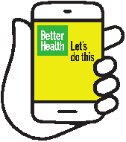It builds a picture of how children are growing to help plan better health and leisure services for families.

**What** **we** **know** **from** **the** **data** **collected** **so** **far**

•Most children in Reception and Year 6 are a healthy weight.

• Around one in ten children in Reception is very overweight. This doubles to one in five children by year 6. • The number of very overweight children in Year 6 is increasing year on year

• Most children who are overweight in Reception will remain so or become even more overweight for their age by year 6 without action to achieve a healthier weight.

Because many children are overweight, we are all becoming used to seeing heavier children as the norm. It means we cannot always tell when a child is overweight. That is why many parents find it helpful to have an objective measurement of how their child is growing. More than 8 in 10 parents say this information is helpful and they can then make decisions about their child’s lifestyle and wellbeing to make changes, or seek support if necessary.

**Why** **achieving** **a** **healthy** **growth** **is** **important**

When children are a healthy weight, they feel better about themselves. They find it easier to play and learn. And they are more likely to grow up healthy too. Helping them to be a healthier weight when they are

a child can set up their health and wellbeing for life.

You can encourage the whole family to enjoy eating healthily and being active which will help your child achieve and maintain a healthier weight. Children who see their parents, grandparents and carers following a healthy and active lifestyle tend to join in and learn by example. These habits become

a normal part of everyday life for the whole family.

Green speech bubble that contains the following text: What we know from the data collected so far
•Most children in Reception and Year 6 are a healthy weight.
• Around one in ten children in Reception is very overweight. This doubles to one in five children by year 6. • The number of very overweight children in Year 6 is increasing year on year
• Most children who are overweight in Reception will remain so or become even more overweight for their age by year 6 without action to achieve a healthier weight.
Because many children are overweight, we are all becoming used to seeing heavier children as the norm. It means we cannot always tell when a child is overweight. That is why many parents find it helpful to have an objective measurement of how their child is growing. More than 8 in 10 parents say this information is helpful and they can then make decisions about their child’s lifestyle and wellbeing to make changes, or seek support if necessary.

Why achieving a healthy growth is important
When children are a healthy weight, they feel better about themselves. They find it easier to play and learn. And they are more likely to grow up healthy too. Helping them to be a healthier weight when they are
a child can set up their health and wellbeing for life.

You can encourage the whole family to enjoy eating healthily and being active which will help your child achieve and maintain a healthier weight. Children who see their parents, grandparents and carers following a healthy and active lifestyle tend to join in and learn by example. These habits become
a normal part of everyday life for the whole family.
© Crown copyright 2022

Department of Health and Social Care

This publication is licensed terms of the Open Government Licence v3.0 except where otherwise stated. To view this licence, visit nationalarchives.gov.uk/doc/open-government-licence/ version/3 Where we have identified any third party copyright information you will need to obtain permission from the copyright holders concerned.



**For** **more** **information** **on** **helping** **your** **family** **lead** **a** **healthy** **life,** **please** **turn** **over.**



**Better Health Families is here to help**

**your family be healthy and happy**

**Sign up for NHS Healthy Steps emails**

Sign up for 8 weeks of Healthy Steps emails to help your family make small changes to make a big diﬀerence. We’ll send you lots of budget-conscious, simple family recipes, fun games and healthy swaps!

[Visithealthysteps.uk](https://healthysteps.betterhealth-healthierfamilies.co.uk/signup/print) or scan the QR code to get started!

**Be Sugar Smart**

Kids are having over double the amount of sugar than they should. Too much sugar is bad for teeth and can lead to weight gain. But don’t worry, we have some simple swaps to help you be sugar smart and cut back.

Sugary drinks are bad for teeth and lead to decay. Swap ﬁzzy drinks, juice drinks and ﬂavoured milks for water, lower-fat milks and no added sugar drinks. Limit fruit juice to no more than 150ml a day and stick to meal times.

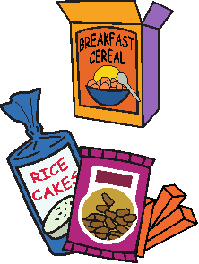Eating breakfast every day is important, but some breakfast choices have

much more sugar than you think. Opt for plain porridge, shredded wholegrain or plain wholewheat biscuit cereals. Help your kids towards their 5 a Day by adding in chopped fruit.

Sugary snacks can all add up! Fruit and vegetables are always the best snack. But when choosing packaged snacks, stick to two a day max.

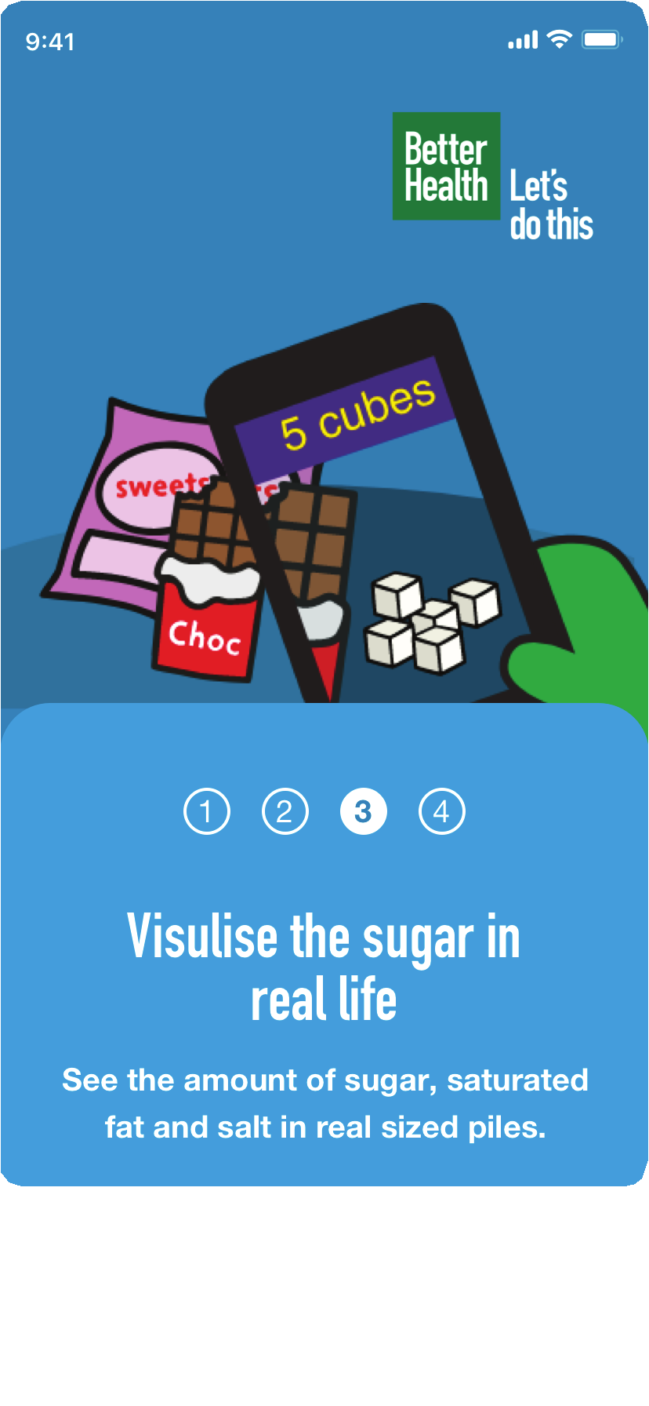

**See what’s really in your food and drink**

Download the FREE [NHS Food Scanner app](https://www.nhs.uk/healthier-families/food-facts/nhs-food-scanner-app/) to see how much sugar, salt and saturated fat are in your favourite food and drinks, and to ﬁnd healthier swaps.

[Find Better Health Families on Facebook](https://www.facebook.com/betterhealthfamilies)