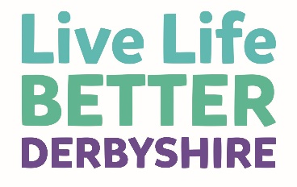
Relaxation & Stress Relief
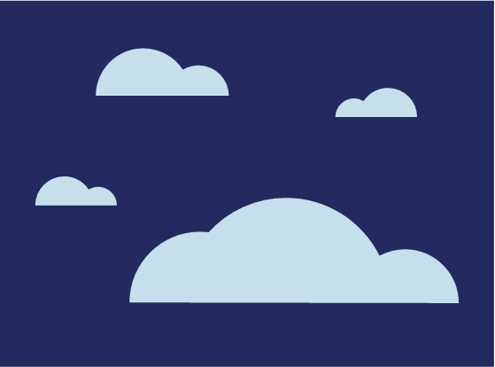
What is Stress?
Stress describes how it feels when we don’t have the resources to cope with the demands our life is placing on us; stress can lead to us feeling overwhelmed and physically and mentally on edge.
Many of us experience some stress in our day to day lives and we know that what one person finds stressful may not be a problem for someone else; we are all different.
We also know that long term stress can build up over time, and that some people are more likely to develop problems with stress than others.
If you have particular traits such as being competitive, highly driven, impatient or a ‘perfectionist’ then you are more likely to get stressed and find it more difficult to relax and switch-off.
Learning more about your own patterns of stress and coping can help you manage them better.
Stress is a natural physiological reaction that is designed to protect us.
It makes us alert and ready to deal with threats (our fight or flight response) which is good for avoiding immediate danger.
Unfortunately in our modern world the threats are often not the type that can be dealt with by fighting or running away, such as unemployment, poor health, relationship problems or financial hardship.
We can end up feeling threatened but not in a position to change the situation. This can mean we stay in a state of stress or on edge for days or weeks at a time; it can become our default setting.
This is not how our stress system was designed to work and prolonged periods of being at ‘action stations’ is bad for our health; interfering with our bodies healing and self-repair mechanisms.
“I try to be realistic about what I can do that day but more jobs keep coming up and I try to do lots of things at once but don’t seem to get many of them done.
“I end up feeling irritable and wound up and more and more exhausted as each day goes by.”
Live Life Better Client

Take a minute to identify and write down your own current sources of stress.

Signs of Stress
Stress can affect our health in three main ways. Take a look at the examples below and tick the signs that you’ve noticed when you’re feeling stressed.

Physical signs
- Stomach problems
- Sweating
- Feeling dizzy
- Headaches
- Muscle tension or pain
- Dry mouth
- Sexual problems
- Breathlessness or palpitations

Emotional signs
- Feeling irritable
- Feeling anxious or tense
- Feeling low in mood
- Feeling not interested in things
- Feeling low in self esteem
- Finding it hard to concentrate
- Finding it hard to remember things

Behavioural signs
- Temper outbursts
- Drinking or smoking more
- Changes in eating habits
- Stopping doing usual activities
- Stopping seeing friends or family
- Rushing around
Experiencing some of these signs might mean you are experiencing stress.
Research shows that there are many links between health and long term risks of stress such as the driving up of blood sugar, disturbed sleep and fatigue, increased storage of fat in our bodies, as well as negative effects on our immune system.
Over time these factors link to increased likelihood of other health problems such as heart disease. So none of this is good news for our overall health or our weight loss efforts.

Tackling Stress
Whilst the effects of stress might sound scary and the causes may seem overwhelming, the good news is that there are many simple ways to tackle stress.
You have now identified some things in life which you currently find stressful, and have also identified your own signs and symptoms of stress.
Already you are becoming more aware of how stress is affecting you and research shows us that this increased awareness is the first important step.
Taking some time to recharge your batteries, stay connected with friends and family, and do activities that you find enjoyable and relaxing can all help increase your coping resources.
Next you need to consider how to take control over the causes and effects of stress.
Problem solving difficult areas in your life can help you to confront and deal with them in an active way whether this be setting new priorities, managing your time differently or learning to say no and not feeling guilty.
Other ideas to improve your overall sense of wellbeing can be found in our leaflet ‘Finding Happiness’.
You can also teach yourself specific simple exercises to achieve the opposite to a stress response in your body, mind and behaviours, and reach a state of relaxation.
Whilst many people talk about relaxation, how many of us actually know what it means and most importantly what it feels like? The actual definition of relaxation is:
“The state of being free from tension and anxiety.”
Relaxation can actually be much more than this; it is a state which feels wonderful and, if experienced through regular practice, can increase our wellbeing and leave us feeling joyful, or even blissful!
At a physical level relaxation counteracts all the effects that stress has on our minds and bodies, so it’s a perfect way to protect yourself from the damaging effects of stress, even when the causes may be difficult or impossible to change.
Even a short 20 minute period of relaxation each day can give your system a deep rest that is protective.
Many people think they are relaxing when they are actually just distracting themselves from the stress in their lives, such as through watching television.
Even a short 20 minute period of relaxation each day can give your system a deep rest that is protective.
This may have some benefit, but is not the same as deep physical relaxation where muscles relax, blood pressure goes down, and the body’s fight or flight response is switched off for a while.
When you are in a deeply relaxed state your body’s healing and repair mechanisms are allowed to work normally, so it’s definitely worth making some time for relaxation on your weight loss journey.

Relaxation Exercises
The following four exercises are a great start for introducing relaxation. Experiment with them and see which works best for you. Remember that relaxation is a skill and like any skill it needs practice to improve.
To experience relaxation it is important to not ‘try too hard’ but instead think of it as a process of letting go. Try and identify key times that you will set aside for practising relaxation and make time for it in your daily routine.

Mindfulness
This is the practice of focussing on our current experience. For most of us our minds are a constant blur of thoughts, we are constantly looking for connections, thinking over past events or imagining or planning for future events. While this can be useful it isn’t exactly relaxing!
Mindfulness is a great way to encourage relaxation, it involves clearing our mind and focussing on what we are experiencing at that exact moment. For example, if we are washing up we will typically be elsewhere, daydreaming.
By being mindful we would be noticing the temperature of the water on our skin, the texture of the sponge and the smell of the bubbles. Clearing our mind in this way and focussing on the present moment is a great way to begin to relax.
Mindfulness does take some practice and you may find your mind wanting to wander – this is perfectly natural and okay to do. Rather than fighting your attention just acknowledge that your mind has wandered and redirect it without judgement.
Try and think of some times when you could be more mindful, such as when in beautiful countryside, eating a meal, in the company of friends or literally any situation you might experience.

Visualisation and Anchoring
Many of us will remember moments from our past when we felt really relaxed and at peace, this may be a moment on holiday or a family day out.
Try and think of an example of this. Take a few moments to recall the scene, recall what you see, hear, feel and even smell. Try to absorb yourself in the experience. This should make you feel relaxed and content; enjoy this feeling for a short while.
You can now ‘anchor’ this feeling. Anchoring is the process of using a physical trigger to produce an emotion or feeling.
When you are in your relaxed state let the intensity of the scene build. As the scene and associated feelings build, gently squeeze your thumb and first finger together and hold them until the feelings are at their peak. Now you have set your first relaxation anchor!
With practice of this process you should find that you are able to reproduce the feelings of relaxation by just squeezing your finger and thumb together.
The more accurately you reproduce the anchor, for example the pressure between finger and thumb, the speed of the squeeze, the more it will bring on the feelings you originally anchored.

Breathing Exercises
When you are anxious or stressed you may notice that your breathing rate increases, this may make the feeling worse.
Our physical and mental states are linked so that a mental state will produce a physical response and a physical state will produce a response in the mind. We can use this to our advantage when we are feeling stressed or anxious through a simple breathing exercise.
Take a moment to find a quiet, comfortable spot. This may be a chair or bed. Once you are settled take a 4 second breath in, preferably through the nose, hold for 2 seconds and then a 6 second breath out, again through the nose.
Use a stomach breathing style, if you place a hand on your stomach you should be able to feel it rise on the in breath.
Keep going at this pace for a short while. Notice any feelings you get as you control your breathing. Whilst this pace of breathing may feel hard at first, with regular practice you will be able to slip into it more easily and enjoy the associated benefits, even in stressful situations.

Calming Your Mind
Another way of relaxing is to focus on your breathing, without attempting to control it, and every time you breathe out, think about a word such as ‘relax’ or ‘calm’ to soothe yourself.
As thoughts pop into your mind, simply bring your attention back to your word and the feeling of breathing out.
Your mind is bound to wander, so simply bring your attention back to your breath and your chosen word when you realise you are following other trains of thought.
With practice you will find that you go for increasing periods of time without other thoughts intruding, and as your mind becomes more still your whole body and mind will relax more deeply.
Remember, all relaxation skills practice should be effortless. Simply allow yourself to go deeper and deeper the more you do it.
There is no right or wrong way to achieve relaxation, different techniques may be more or less effective for you. The key is to try a few out and when you find one you are happy with, take time out for lots of practice!
To get more help and support visit our website at livelifebetterderbyshire.org.uk or call 0800 085 2299.

