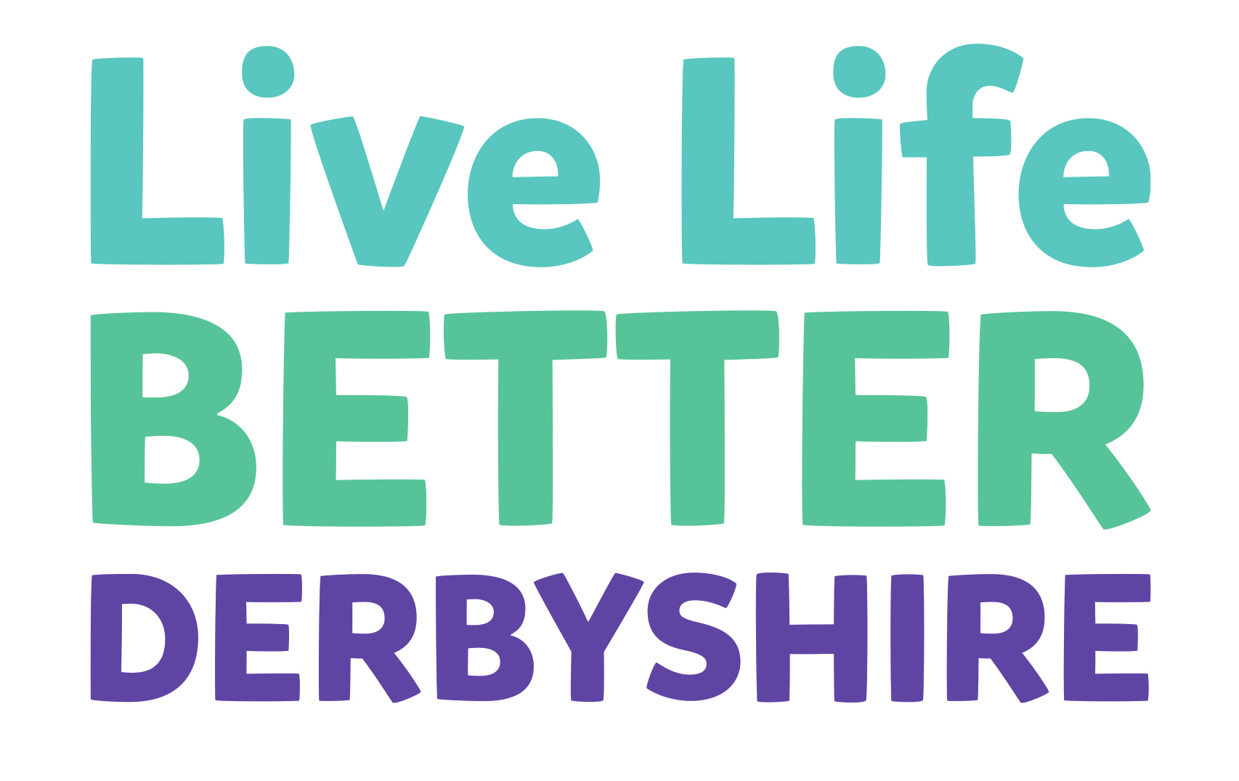
Emotional Eating

Our Eating Habits
Our eating habits can often be linked to our emotions, whether we’re feeling happy, sad or angry, we can all turn to food for comfort and satisfaction.
This habit of ‘emotional eating’ or ‘comfort eating’ can become a problem if it becomes a regular habit as this tends to result in overeating and weight gain.
While there is no miracle cure for the many feelings — happy and sad — that we’ll experience throughout our lives, the good news is that there are plenty of ways to retrain our brains to help us manage these feelings and to think about food in different ways.
To lose weight successfully it’s important to be able to recognise and separate out your emotions from your eating.
Are any of these feelings familiar?
Feeling out of control Depression Boredom Hopelessness
Sadness Low mood Guilt Relaxed
Fear Self-criticism Anger Love
Happy Excited Self-loathing Frustration
Can you think of any others that you might have experienced?
It’s good to start thinking about how your feelings link to food so that you can begin to recognise any habits that you might have built up over time.
The more you can understand about how your feelings are affecting you, the easier it will be to do something about it, and the more you will begin to feel in control.

Your Food Diary
Your food diary is a good opportunity to make a note of your feelings around food and how these might be affecting you reaching your goals.
We’ve made a checklist of questions that it might be handy to keep in mind while looking through your food diary.

Checklist
Which feelings are leading you to eat more than you really need to?
Are there any triggers that keep occurring?
When and where do your problem feelings tend to crop up? For example, do you eat alone or late at night because you feel embarrassed about the amount you are eating?
How do you feel after you’ve acted on your craving or emotional impulse?
What helps to make the feeling stronger or weaker?
How long have you experienced these feelings?

Managing Your Emotions
Hopefully you’ve now picked up on how your feelings are influencing your eating patterns.
It’s comforting to remember that most feelings are temporary and that we can help you to learn new ways of coping with them while they’re around
If you’re experiencing difficult feelings nearly all of the time, and they are seriously impacting on your life, it is really important to discuss this with a healthcare professional. Ask one of our team for some more advice.

Our Top Tips
Here we’ve listed some of our top tips for helping to recognise, and manage, emotional eating.
Be aware of triggers
Be aware of your emotional triggers. Put a plan in place for how you can deal with these triggers when they crop up to help build up healthy habits for your future.

Body over mind
Learn to recognise your physical hunger from your emotional hunger by asking yourself this question: Am I really hungry or do I just want to change how I feel? Then wait a few
minutes to see if the urge to eat goes away. Make a note of each time you succeed and you’ll start to feel more in control.

Listen to your feelings
The more emotions are ignored or avoided, the more strongly they will tend to return. Remember that all feelings are temporary and will come and go throughout your life.

Find new sources of comfort
Such as talking to a friend or family member about how you feel or doing something you really enjoy like listening to music, reading a book, or using relaxation techniques. You can also try working through your feelings by doing some sort of physical activity.

Confront your feelings
Confront the feeling that’s making you feel uncomfortable and try to think about changes you can make to experience the feeling less often.

Choose a healthy alternative
Replace the unhealthy foods in your house with healthier versions so that when you do feel like comforting yourself with a snack you’re less likely to gain weight.

Slow down
Slow down, savour each mouthful and take real pleasure from the food you are eating. Chances are you’ll feel fuller for longer!

Reminders
Each time you reach for food remind yourself of your own personal reasons for losing weight and then decide if you really feel that it’s the right thing for you to eat.

My Emotional Eating Strategies:
Think about which of the ideas in this leaflet you might already be using and if you have any of your own ideas to add make a note of them here so you can easily remind yourself when you need them the most.
1.
2.
3.
4.
5.

If you’re experiencing difficult feelings nearly all of the time, and they are seriously impacting on your life, it is important to discuss this with a healthcare professional. Ask one of our team for some more advice.

For more help and advice visit www.livelifebetterderbyshire.org.uk

